https://www.jdoodle.com/embed/v0/5PRC
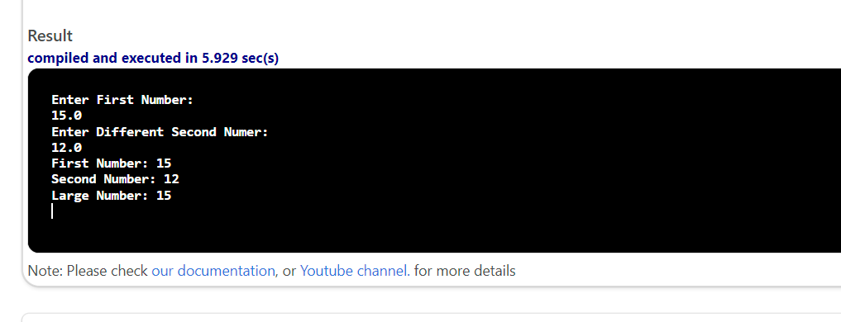

#include <iostream>

using namespace std;

int main()
{
double n1, n2, larger;
cout<<"Enter First Number:"<<endl;
cin>>n1;
cout<<"Enter Different Second Numer:"<<endl;
cin>>n2;
if (n1 >= n2) {

larger = n1;

}

else {

larger = n2;
}
cout<<"First Number: "<<n1<<endl;
cout<<"Second Number: "<<n2<<endl;
cout<<"Large Number: "<<larger<<endl;
return 0;
}

